Front Rack on Treadwell Bicycles

Update: Rack Re-Attachment Parts Now Available

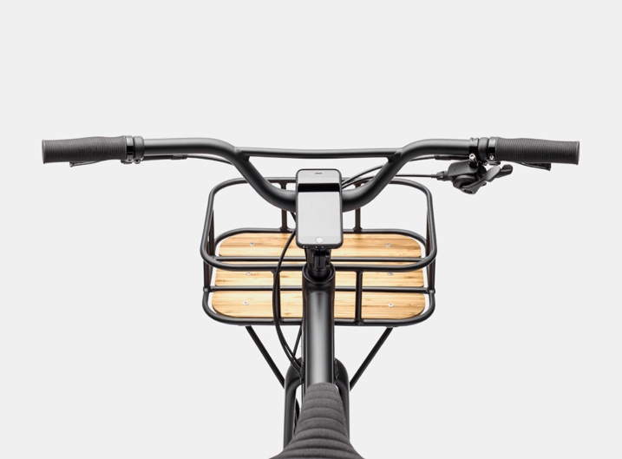
STOP RIDING UNTIL YOU HAVE REMOVED THE RACK

- Follow the removal instructions below

- Save all removed rack parts

- After the rack is completely removed, you can
keep riding your bicycle

- Contact your local authorized Cannondale
dealer to re-install the rack with upgraded
parts, at no charge

At Cannondale, we know our riders demand the highest levels of performance, quality, and safety, and we hold ourselves and Cannondale products to that standard.

As we announced previously, following a few reports of issues with the bolts that attach the front rack on some Cannondale Treadwell bicycles that caused the rack to become detached from the bicycle and abruptly stop the front wheel, we elected to conduct a recall of the rack in order to provide riders with a more robust attachment system.

We have now completed testing and secured the approvals required to conduct a formal recall and re-install the rack with upgraded parts.

Cannondale dealers and riders should remove the rack from any Treadwell bicycles and save rack parts for re-attachment. It is easy to remove the rack - instructions are included below, and a step by step video is available on the Cannondale Mobile App and cannondale.com
Once the rack is removed, you can keep riding your Treadwell.

Please contact your local authorized Cannondale dealer or Cycling Sports Group to arrange for an authorized Cannondale dealer to re-install the rack with upgraded parts, at no charge. Consumers can remove the rack on their own, but it must be re-installed by an authorized Cannondale dealer.

We apologize for this inconvenience and thank you for your patience, and for riding Cannondale.
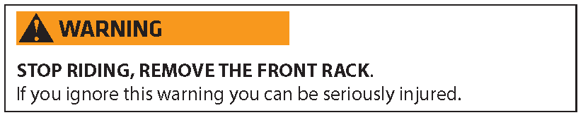

Rack Removal Instructions

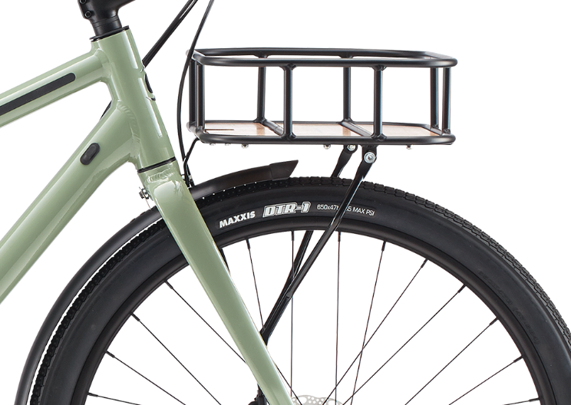
The front rack is attached to the bicycle at three places: the fork crown and on both fork legs. See Figure 1
1

You will not have to disassemble the rack.

You may need the following tools:

• 5 mm allen wrench
• 8 mm regular wrench
(or adjustable wrench)
• Philips head screwdriver

Please also visit the Recalls & Notices section of cannondale.com for a video of these instructions.

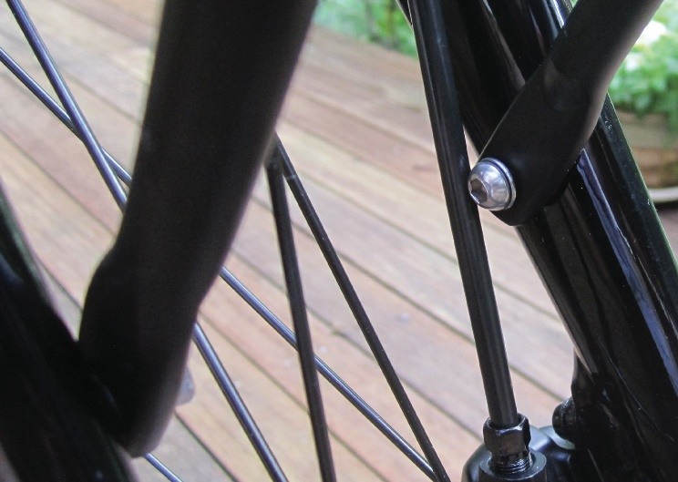
To remove the rack:
2

- Lean the seat of the bike against a wall or other stable object, so the bike cannot fall over or move while you are removing the rack.

- Find the bolts that secure the rack struts to the fork legs, as shown in Figure 2.

Use the appropriate tool to turn the bolts
counter-clockwise until you can remove
the bolt and the washer under it from both
fork legs.

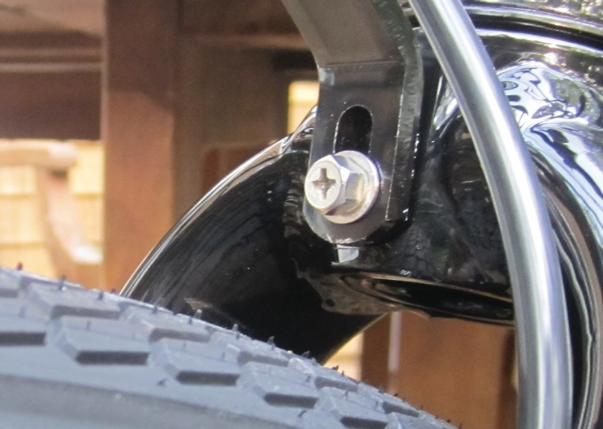
- Find the bolt at the top of the fork that secures the rack bracket, as shown in Figure 3.
3

Use the appropriate tool to turn the bolt counter-clockwise until you can remove the bolt and the washer under it.
When this bolt has been removed, lift the rack up and forward to remove it.

- Store the removed rack for later re-installation by a Cannondale dealer, once we have received governmental approvals to conduct a recall to replace the rack mounting hardware.

