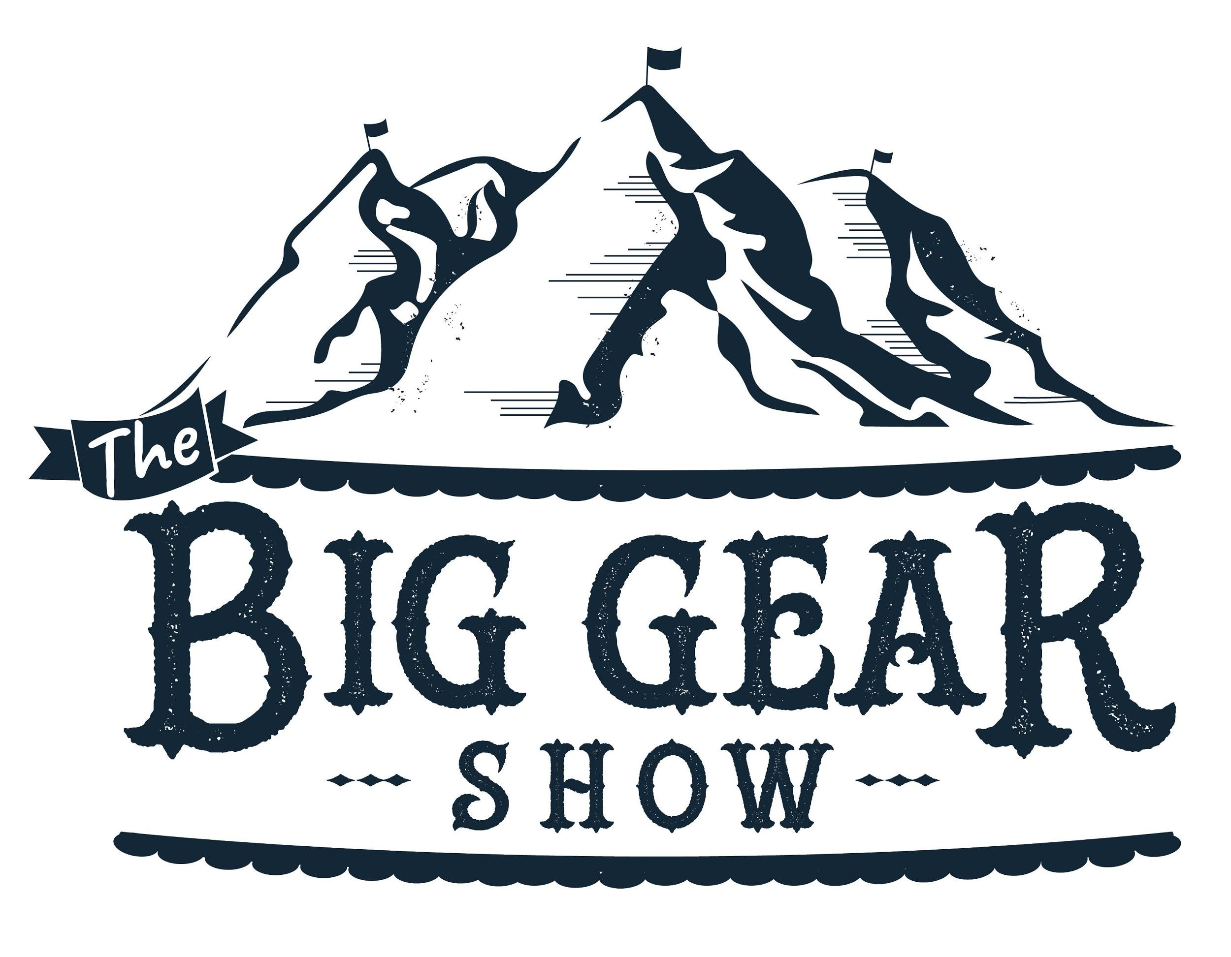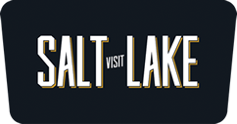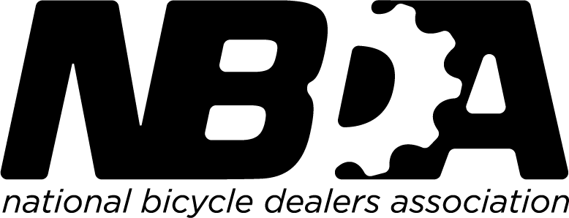

FOR IMMEDIATE RELEASE

Gavin Young, Marketing & Communications Director
gavin@thebiggearshow.com
828-552-8288

The Big Gear Show Announces Robust Retailer Lodging Incentive

Salt Lake City (February 2020) — The Big Gear Show (BGS), the outdoor-industry’s new hardgoods-focused trade show, is unveiling its retailer incentive program. The retailer-friendly reimbursement program, carried over from Paddlesports Retailer, aims to make show attendance more affordable for the show’s core specialty retailer attendees. Aside from this incentive, the show also features retailer-focused educational programming and an outdoor demo experience (details coming soon) designed primarily for retailers.

Retailer Incentive Program
For a limited time only, qualified retailers can earn up to $150 per night, beginning the night of July 22st and continuing through July 24th—for a total reimbursement of up to $450. The deadline and the last day to register for a full reimbursement in The Big Gear Show’s retailer lodging incentive is Sunday, March 1, 2020. After this date, the reimbursement offer decreases to $75 per night (for a total of up to $225) until June 1, 2020, when the lodging incentive program closes. To participate retailers must:

- Register to attend The Big Gear Show at this link by March 1, 2020.
- Book lodging in The Big Gear Show Room Block by April 1, 2020 (details coming soon).
- Send confirmation of lodging, including confirmation number, location and dates to info@thebiggearshow.com by April 1, 2020.
- Attend the show, and pick up their badges in person at show check-in.

The show offers one reimbursement per shop, and reimbursement checks will be issued within 60 days after the show. Kent Cranford of Motion Makers Bicycle Shop comments: "This is great news! I was already planning on bringing several key staff for this show and this will make it even easier on my budget. I'm super-excited for Utah!”

Hill Abell, owner Bicycle Sport Shop, adds, “Pay me to attend the show where I can meet my fellow bike dealers, see the hot new product, learn trade skills at seminars and training sessions, and go ride Park City while I’m there? What a deal, sign me up!”

Ed McAlister of River Sports has attended Paddlesports Retailer for the past three years and says, “As shows are expensive to attend, not only in time away but in travel and lodging, it is extremely beneficial to receive some reimbursement. This allows you to take additional personnel as well. It’s important to be with like minded people with the product you need to see when attending any show.”
About The Big Gear Show

The Big Gear Show is the outdoor industry’s first-ever national B2B2C gear show ‘for retailers, by retailers.’ The show takes place July 21-25, 2020 in Salt Lake City, Utah. The National Bicycle Dealers Association has endorsed The Big Gear Show as the official trade show of the bicycle industry. The show provides exclusive outdoor and on-site demo opportunities for paddling, biking, climbing and camping, an expansive marketplace and an unsurpassed cultural experience for exhibitors, retailers, media and industry advocates alike. For more information, visit www.thebiggearshow.com or contact info@thebiggearshow.com.

About the National Bicycle Dealers Association

The National Bicycle Dealers Association has represented specialty bicycle dealers in the United States since 1946. The non-profit association offers numerous programs for dealers, with an emphasis on education, research, communication and advocacy. For more information on the NBDA, visit their website at www.nbda.com.

- www.thebiggearshow.com –

