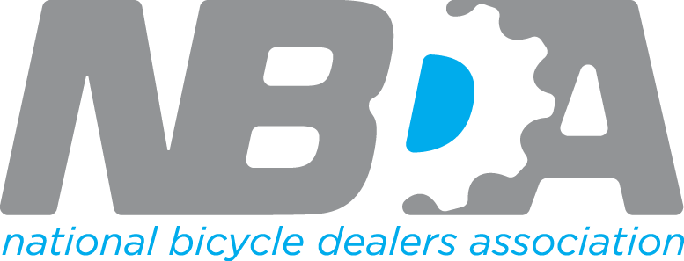

FOR IMMEDIATE RELEASE

National Bicycle Dealers Association Announces Results of 2023 Fall Board Election

Irvine, CA- November 27th, 2023 - The National Bicycle Dealers Association (NBDA) is delighted to announce the results of its 2023 Fall Board Election, where two outstanding candidates were elected by a majority member vote. Joining the NBDA Board of Directors are Clark Butcher from Victory Bicycle Studio in Memphis, TN, and Greg McDonald from Ridleys in Calgary. Both individuals bring a wealth of industry experience and expertise to the NBDA.

Newly Elected Board Members:
- Clark Butcher - Victory Bicycle Studio, Memphis, TN
Clark Butcher, a seasoned industry professional, has a track record of service on various non-profit boards of directors and a local bank. With a successful history in social media, Clark emphasizes the importance of making a meaningful impact beyond mere metrics. His strategic thinking, confidence, and drive make him a valuable addition to the NBDA Board.

- Greg McDonald - Ridleys, Calgary
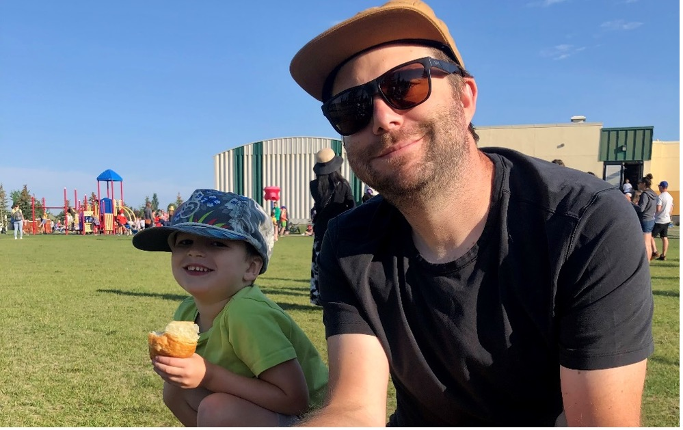
Greg McDonald brings fresh eyes, vision, and a unique approach to the NBDA Board. Advocating for a Canada-specific portion of the vision, Greg believes in enhancing the NBDA's outreach to non-members. He aims to position NBDA membership as an investment in personal and professional growth, encouraging individuals to be their own leaders and shape their destinies.

Re-elected Board Members:
- Phil Cohen - Chain Reaction, Evans, Georgia
- Kent Cranford - Asheville, NC
- Peter Henry - Landrys, Boston , MA
Peter, Phil and Kent, all re-elected, continue their tenure on the NBDA Board, bringing years of experience and expertise. Phil served as the NBDA Treasurer for multiple years, and Kent, with over 40 years in the bike business, has been a valuable member of the Best Practices Committee.

Peter Henry, re-elected as Board Chair, emphasizes the NBDA's mission to call retailers to excellence. He envisions refining and expanding the association's approach to providing information, education, and data. Peter aims to build a stronger retailer community through events, both remote and in-person, fostering inclusivity and diverse perspectives.

These esteemed individuals have demonstrated an unwavering commitment to the NBDA's mission and have played integral roles in steering the organization toward its goals.

The NBDA Board of Directors is a driving force behind the organization's initiatives to support and promote bicycle dealers nationwide. Their participation and contributions are instrumental in shaping the future of the NBDA. We are confident that the combined expertise of our newly elected and re-elected board members will enhance our collective efforts to advance the bicycle retail industry.

NBDA's Ongoing Initiatives:
The NBDA is committed to its mission of supporting and promoting bicycle dealers. Key initiatives include the NBDA Retailer Summit, Profitability Project, Webinars, Bicycle Retailer Radio, and Advocacy efforts like E bike Safety and Supplier Best Practices. These programs provide valuable resources, networking opportunities, and education for bicycle retailers.

Those interested in contributing to the future of the NBDA by joining the Board can write to info@nbda.com for consideration in the Fall 2024 elections.

###

About the National Bicycle Dealers Association (NBDA)
The NBDA is a non-profit organization dedicated to supporting and promoting independent bicycle dealers. Through various initiatives, education programs, and networking opportunities, the NBDA strives to elevate the bicycle retail industry and empower dealers for long-term success. For more information about the NBDA and its initiatives, please visit www.nbda.com.

